00000000000000000000000000000000000000000000000000000000000000000000000000000000000000000000000000000000000000000000000000

JC Rupe

Date: **April 4, 2017**

Version: **1.0.1**



**Project JIM:**

*LD Dispatch Application*

**IT Project Management Office**

Document Revisions

|  |  |  |
| --- | --- | --- |
| Date | Version Number | Document Changes |
| 2016/12/30 | 1.0.0 JC | Document initial creation/completion. |
| 2017/01/03 | 1.0.0 JC | Edited a small amount of the wording. Section 1.1. |
| 2017/01/17 | 1.0.0.1 JC | Added document name to footer. |
| 2017/04/04 | 1.0.1 JC | Update the document with changes to the LD Dispatch application. |
|  |  |  |
|  |  |  |
|  |  |  |
|  |  |  |
|  |  |  |

Contents

1 LD Dispatch Application 4

1.1 Important Information 4

1.2 Navigate to LD Dispatch Application 4

1.3 Features – Display Panels 5

1.3.1 Selection Criteria Panel 5

1.3.2 Legend Panel 6

1.3.3 Filter Criteria Panel 7

1.3.4 Job List Panel 8

1.3.5 LD Board Panel 9

1.4 Additional Features 11

1.4.1 Driver Information Window 11

1.4.2 Service Activity Details Window 12

2 LD Dispatch Management 14

2.1 Assign a Driver 14

2.2 Un-Assign a/all Driver(s) 17

2.3 View a Driver’s Information 18

2.4 View a Job’s details 18

2.5 View and Add Customer Call Log 19

2.5.1 View Call Log 19

2.5.2 Update WMM/SI 19

2.5.3 Add New Call Log 20

2.5.4 Update Call Log 20

2.6 Modify a Job’s Service Type 22

2.7 Schedule Delivery and Create Release 23

2.8 Transfer a Job 25

2.9 Training Event 26

2.9.1 Create Training Event 26

2.9.2 Remove Training Event 27

2.10 Day Blocks (Events) 28

2.10.1 Create a Day Block 28

2.10.2 Remove a Day Block 29

# LD Dispatch Application

This document explains how to use the LD Dispatch application. The LD Dispatch application is used to assign drivers to intrastate and interstate Move/Service Activities.

## Important Information

* The preferred browser to use is Microsoft Explorer, although, Chrome and Firefox should also work.
* When referring to “jobs”, this means the Move/Service Activities.
* Unless otherwise noted, it’s assumed that you have already navigated to the LD Dispatch application.

## Navigate to LD Dispatch Application

1. Navigate to the LD Dispatch application.
   1. See your supervisor if you don’t have this link.
2. The LD Dispatch window will open and display.
   1. Displayed are 5 panels.
      1. **Selection Criteria panel** – The top left panel.
         1. This provides filters of the job list and LD board.
         2. It also allows the user to change the start date for the range shown on the board.
      2. **Legend panel** – The top right panel.
         1. On the right side of this panel, a color coded Legend is displayed for the convenience of the user.
      3. **Filter Criteria panel** – The upper left panel, just below the main search criteria panel.
         1. This provides controls to filter the jobs shown.
      4. **Job List panel** – The lower left panel.
         1. This shows all the jobs that need to be assigned to drivers across a spread of dates.
      5. **LD Board panel** – The large lower right panel.
         1. This shows all the jobs assigned to drivers across a spread of dates.

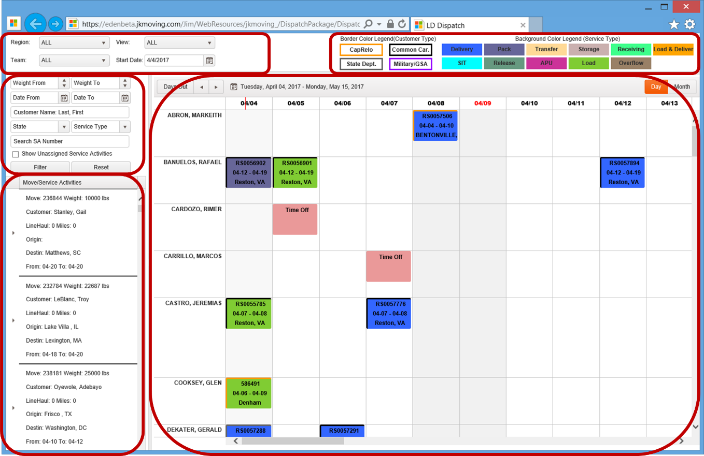

## Features – Display Panels

### Selection Criteria Panel

1. **Region** – The Region where the job is to be performed.
   1. Options are:
      1. ALL – All regions will be displayed.
      2. Short Haul – A select group of states (mostly the eastern seaboard) to which we can deliver in a day.
      3. DP3 Region 1 – Idaho, Oregon, Washington
      4. DP3 Region 2 – California, Nevada
      5. DP3 Region 3 – Arizona, New Mexico, Utah
      6. DP3 Region 4 – Montana, North Dakota, South Dakota, Wyoming
      7. DP3 Region 5 – Colorado, Kansas, Missouri, Nebraska
      8. DP3 Region 6 – Arkansas, Louisiana, Oklahoma, Texas
      9. DP3 Region 7 – Iowa, Michigan, Minnesota, Wisconsin
      10. DP3 Region 8 – Illinois, Indiana, Ohio
      11. DP3 Region 9 – Connecticut, Maine, Massachusetts, New Hampshire, New Jersey, New York, Pennsylvania, Rhode Island, Vermont
      12. DP3 Region 10 – Delaware, District of Columbia, Maryland, Virginia, West Virginia
      13. DP3 Region 11 – Alabama, Kentucky, Mississippi, Tennessee
      14. DP3 Region 12 – Georgia, North Carolina, South Carolina
      15. DP3 Region 13 – Florida
      16. DP3 Region 14 – Alaska (Alaska is a domestic destination for some shipments)
2. **Team** – Select the Dispatcher. Selecting a Dispatcher populates the Job List panel with only the drivers assigned to that Dispatcher.
3. **View** – The job origin or destination location.
   1. Options are:
      1. ALL – All will be displayed.
      2. VA – Virginia, including Washington DC
      3. MD – Maryland
      4. VA/MD – Virginia, Washington DC and Maryland
      5. OT – Off Terminal

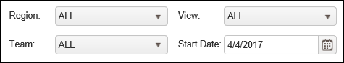

### Legend Panel

1. The colors are displayed on the assigned jobs in the Job List panel.
2. Border Color Legend

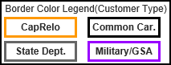

* 1. This legend shows the Customer Type.
     1. CapRelo
     2. Common Car.
     3. State Dept.
     4. Military/GSA
     5. The color is the border around the assigned job.

1. Background Color Legend

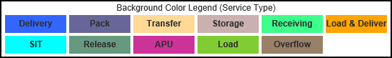

* 1. This legend shows the Service Type.
     1. Delivery
     2. Pack
     3. Transfer
     4. Storage
     5. Receiving
     6. SIT
     7. Release
     8. APU
     9. Load
     10. Overflow
     11. More Than 1

1. For example:
   1. This job is Common Carrier (black border) and is a Delivery (blue background).

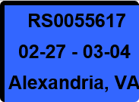

* 1. This job is CapRelo (orange border) and is for SIT (cyan background).

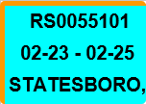

* 1. This job is State Dept. (gray border) and is a Load (medium green background).

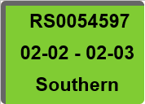

### Filter Criteria Panel

1. **Weight From** and **Weight To** – A range of weights that the jobs Estimated Weight falls into.
2. **Date From** and **Date To** -
3. **Customer Name: Last, First** – The name of the Client being moved.
4. **State** – The Moves origin state.
5. **Service Type** – Select the job Service Type.
   1. Option are:
      1. Pack
      2. Load
      3. Deliver
      4. Unpack
      5. Pack & Load
      6. Load & Deliver
      7. Storage In
      8. Storage Out
      9. Storage Access
      10. Release
      11. Receive
      12. SIT at Origin
      13. SIT at Destination
      14. Transfer From
      15. Transfer To
6. **Search SA Number** – Search by the Service Activity number.
7. **Show Unassigned Service Activities checkbox**
   1. Checking this box will display only the unassigned job’s Service Activities, in the expanded Job List.
   2. Unchecking this box will display all of the job’s Service Activities assigned or not assigned, in the expanded Job List.
8. **Filter button** – Selecting this button will perform the filter and display the jobs, meeting the filter conditions, in the Job List panel.
9. **Reset button** – Selecting this button will reset the Job List panel back to the default values.

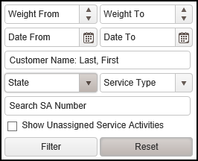

### Job List Panel

1. The jobs listed provide a summary of their particular job.
2. Displayed are:
   1. **Move** – The Move number.
   2. **Weight** – The Estimated Weight of the Move shipment.
   3. **Customer** – The full name of the Client being moved.
   4. **LineHaul** – The Move transportation Estimated Linehaul value.
   5. **Miles** – The distance between Origin and Destination.
   6. **Origin** – The City and State where the Move originates.
   7. **Destination** – The City and State final destination of the Move.
   8. **From** and **To** – The date range for the performance of the job.

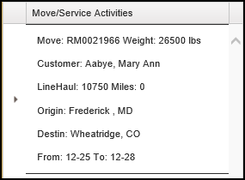

1. **Job(s) to Assign** (Expanded Job List) – This is shown by selecting the expansion button for a specific job.
   1. Displayed are:
      1. **Service Activity** number.
      2. **Service Type**.
      3. **Date** – The date of the job.
      4. **Driver** – The name of the Driver.
      5. The border and background colors give information. See the Legend Panel.

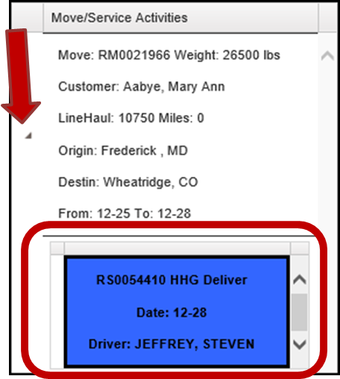

### LD Board Panel

1. By default, the date range displayed is 6 weeks out from the current date.
2. **Left** arrow  – Selecting this arrow decrease the end of the date range by 2 weeks. i.e. If the displayed date range is 6 weeks out, it will reduce it to 4 weeks out.
3. **Right** arrows  – Selecting this arrow increase the end of the date range by 2 weeks. i.e. If the displayed date range is 6 weeks out, it will increase it to 8 weeks out.
4. **Day** view button – This is the default view
   1. The Day view record display grid:
      1. **Driver Name** – The first column contains the names of the Drivers.
      2. **Date** – Each of the other columns represent a calendar day, initially starting with the Start Date entered in the Main Selection Criteria panel.
      3. **Assigned Job** – The grid cells will contain information about the job that is assigned to the Driver on that Date.
         1. Displayed are:
            1. The **Service Activity** number.
            2. The **Date** range of the job.
            3. The **Origin** location of the job.
            4. The border and background colors give information. See the Legend.
5. **Day/Time of Day** indicator – This is a red vertical line that is on the column header for the current date. The line’s position across the header indicates the current time of day. In this example, today is April 4 and the time is 11:30 am.  Note: You can’t tell the exact time from this indicator, just approximate.

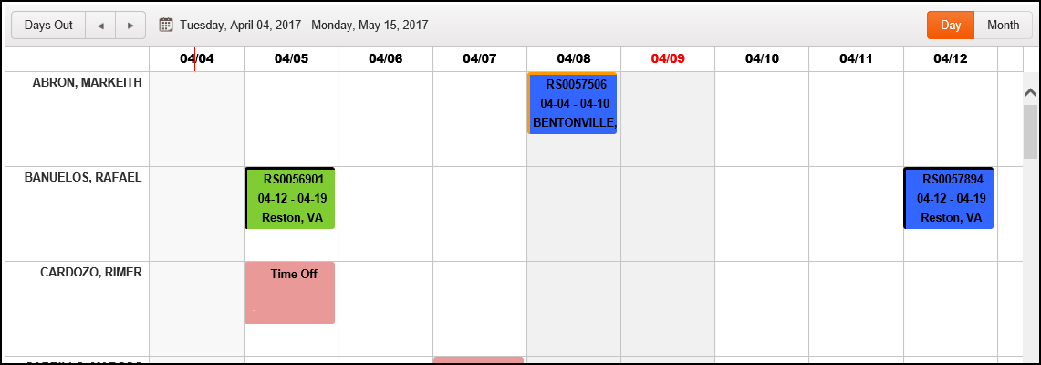

1. **Month** view button – Displays the full month calendar for each Driver. The month displayed is the month represented in the current Start Date entered in the Main Selection Criteria panel.
   1. The Month view record display grid:
      1. **Driver Name** – The first column contains the names of the Drivers.
      2. **Week Day** – The next 7 columns represent each day of the week, starting with Sunday. The week initially starts with the week containing the Start Date entered in the Main Selection Criteria panel.
      3. **Month Grid** – The grid contains every week of the month containing the Start Date entered in the Main Selection Criteria panel.
      4. **Assigned Job/Event** – The month’s grid slots will contain information about the job or event that is assigned to the Driver on that date.
         1. Displayed are:
            1. The **Service Activity** number or the name of the **Event**.
            2. The border and background colors give information. See the Legend Panel.

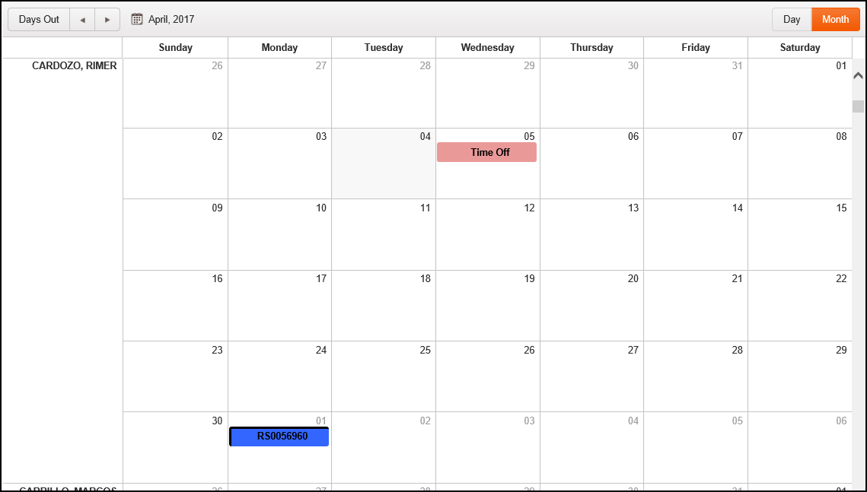

## Additional Features

### Driver Information Window

1. **Driver Name** – The name of the Driver.
2. **Employee ID** – The Driver’s Employee ID number.
3. **Service Location** – The main location from which the Driver works.
4. **License Type** – The License Type of the Driver is displayed in this field.
5. **Cell Phone** – The Drivers cell phone number.
6. **Home Phone** – The Drivers home phone number.
7. **E-Mail Address** – The Drivers email address.
8. **Assigned Truck** – The Drivers assigned truck.

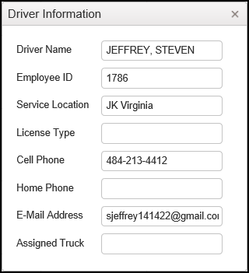

### Service Activity Details Window

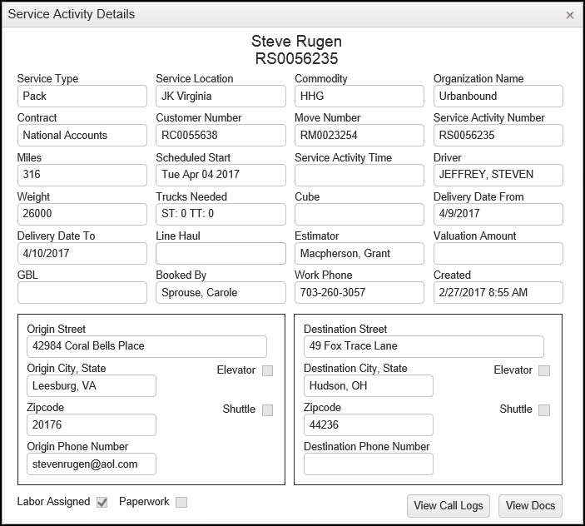

1. Centered across the top of the display window:
   1. **Customer’s** name – The name of the Customer/Contact being moved**.**
   2. **Service Activity** number – The number assigned to the Service Activity.
2. **Service Type** – The type of Service Activity to be performed.
3. **Service Location** – The location of the Service Activity to be performed.
4. **Commodity**
5. **Organization Name** – The name of the organization JK has the contract with.
6. **Contract** – The type of move it is.
7. **Customer Number** – Unique ID number assigned to the customer.
8. **Miles** – The expected total miles traveled for the Service Activity.
9. **Schedule Start** – The scheduled start date. In Eden, this is the date value of the Scheduled Start Time.
10. **Service Activity Time** – The expected start time. In Eden, this is the time value of the Scheduled Start Time.
11. **Driver** – The assigned driver’s name.
12. **Weight** – The estimated weight of the load.
13. **Trucks Needed** – The type and number of trucks needed.
14. **Cube**
15. **Delivery Date From** and **To** – The date range for delivery of the Service Activity.
16. **Line Haul**
17. **Estimator**
18. **Valuation Amount**
19. **GBL**
20. **Booked By** – The name of the Booking Agent or Coordinator.
21. **Work Phone –** The work phone number for the person who booked the Service Activity.
22. **Created –** The date and time the Service Activity was created.
23. **Origin Information –** Address, Phone, Shuttle and Elevator.
24. **Destination Information –** Address, Phone, Shuttle and Elevator.
25. **Labor Assigned** checkbox –
26. **Paperwork** checkbox –
27. **View Call Logs button –** Selecting this button takes you to see the call logs associated with the Service Activity.



1. **View Docs button –** Selecting this button takes you to see documents associated with the Move.



# LD Dispatch Management

## Assign a Driver

1. Enter desired criteria into the Selection Criteria panel.
   1. Each selection will further isolate the Drivers and their schedules displayed.



1. Locate the desired Job.
   1. Enter any Filter criteria into the Job List panel.
   2. Select the “Filter” button.

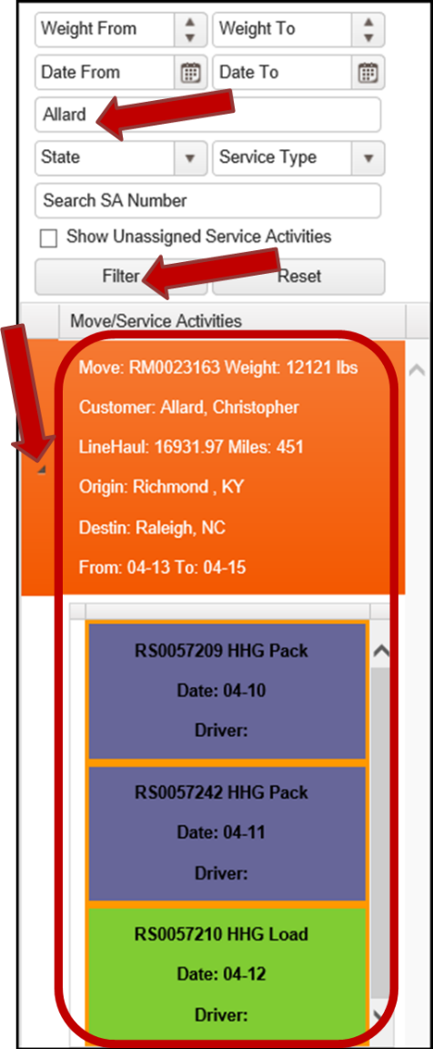

1. Locate the desired Driver.
   1. Scroll, if necessary, to locate the desired driver.
2. Select the desired Job.
   1. The selected Job summary will change color.
   2. View the Service Activity list, by selecting the arrow to the left of the job.
      1. This must be open to assign individual jobs to the driver.
      2. **Note:** The Service Activity list view doesn’t have to be open in order to assign the entire Move to the driver.
3. There are two assignment actions that may now be taken.
   1. Assign one Job from the Move to a Driver.

|  |
| --- |
| Select the Job to be assigned.  a) Note that the Job and the Move will be highlighted in orange.  Select a slot on the calendar line belonging to the Drive to be assigned.  a) Note that the Driver’s slot will be highlighted in orange.    Right click on either the Driver’s slot or on the selected Job.  a) Select the “Assign Driver” option.    The Driver is now assigned to the Job. |

* 1. Assign the entire Move to the Driver.

|  |
| --- |
| Click on the Move and drag it to the Driver’s calendar line.    Drop it on the Driver’s calendar line.  a) **Note:** All unassigned jobs will automatically place themselves on the appropriate dates of service. |

## Un-Assign a/all Driver(s)

1. **To unassign a Driver from a Job**, right click on the specific Service Activity, in the Driver’s calendar slot.
   1. You may instead right click on the Service Activity in the left Job List panel.
2. **To unassign Drivers from all the Jobs in a Move**, right click on the Move in the left Job List panel.
3. A drop down menu will display.
   1. Select the “Unassign Driver” option.

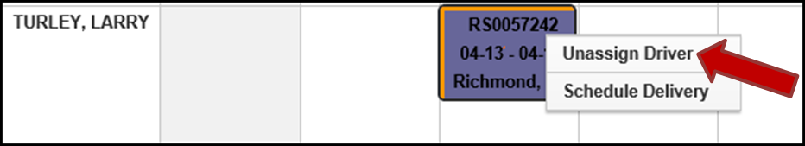

1. The select Service Activity is now no longer assigned to the Driver.

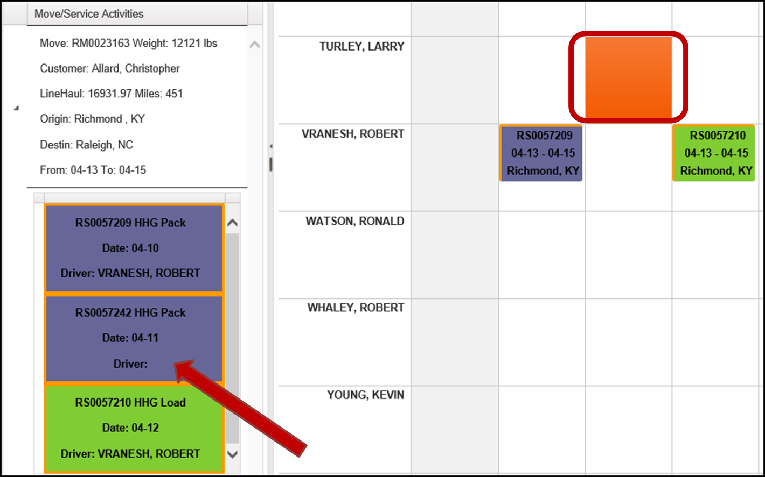

## View a Driver’s Information

1. Locate the desired Driver.
   1. Enter selection criteria into the Main Selection Criteria panel.
   2. Select the “View Schedule” button.
2. Right click in the slot containing the Driver’s name.
3. A drop down menu will display.
   1. Select the “Driver Information” option.

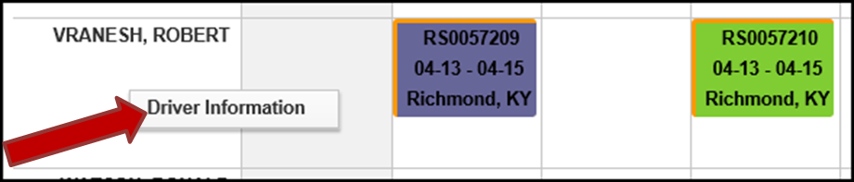

1. The Driver Information window will display.
   1. See section Driver Information Window for more information.

## View a Job’s details

1. Locate the desired Job.
2. Double click on the job.
   1. Note: You may instead double click on the Service Activity in the left Job List panel.

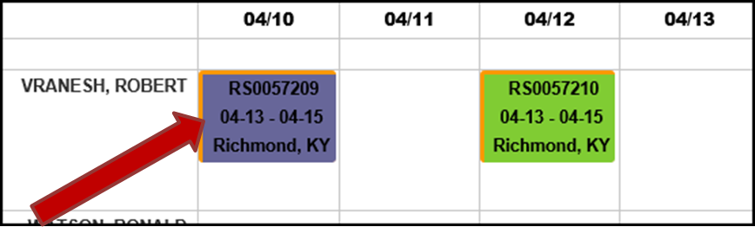

1. The “Service Activity Details” window will open and display.
   1. The displayed data may only be viewed here, not edited. See section Service Activity Details Window.

## View and Add Customer Call Log

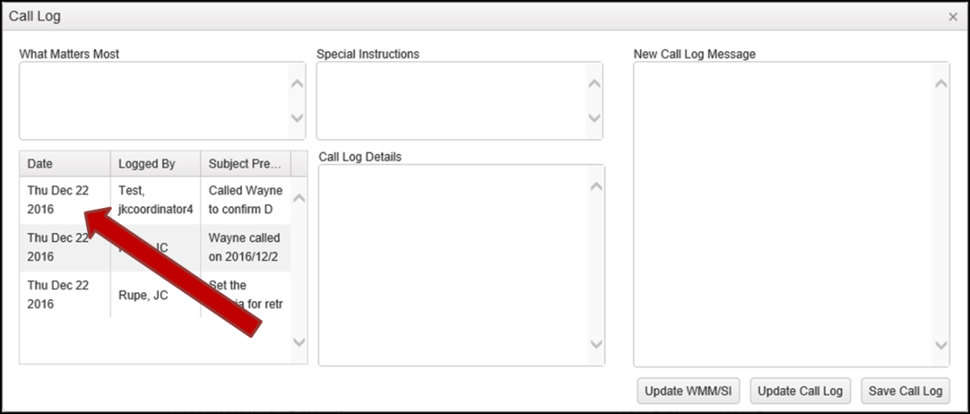

### View Call Log

1. Perform the steps in section View a Job’s details.
2. The “Service Activity Details” window will be displayed.
3. Select the “View Call Logs” button.
4. The “Call Log” window will display.
5. Click on the specific call to view its details.

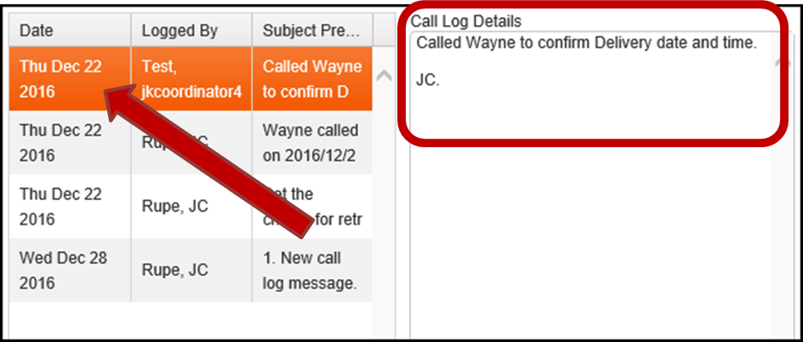

### Update WMM/SI

1. Enter text into the “What Matters Most” field.
2. Enter text into the “Special Instructions” field.
3. Select the “Update WMM/SI” button.
4. These two fields are now updated for the Service Activity.

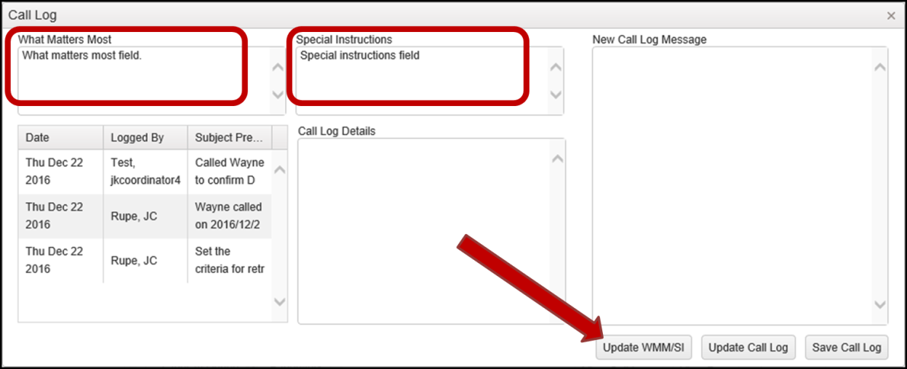

### Add New Call Log

1. Enter text into the “New Call Log Message” field.

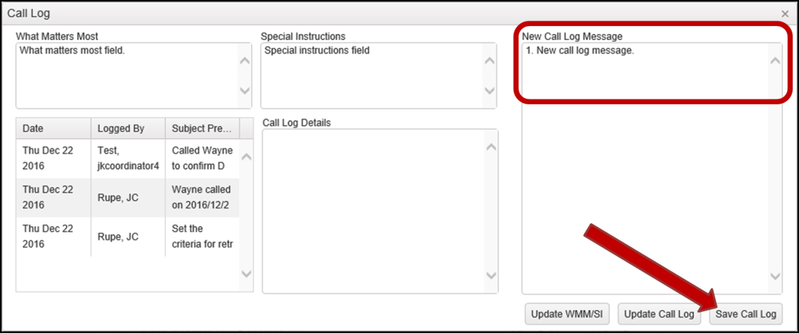

1. Select the “Save Call Log” button.
2. The new Call Log is now saved and displayed.

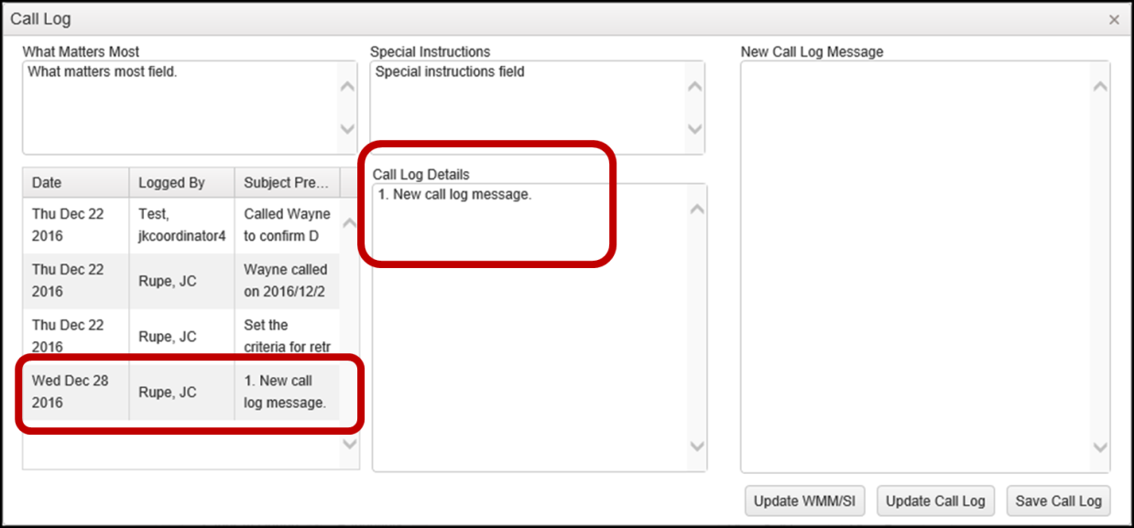

### Update Call Log

1. Select the Call Log to be updated.
2. The details of the selected Call Log will display in the “Call Log Details” field.

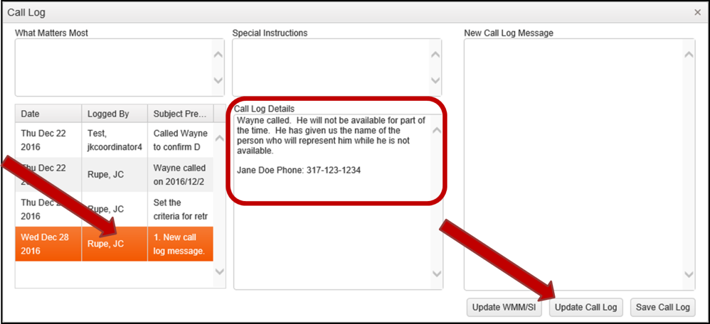

1. Edit the “Call Log Details” field.
2. Select the “Update Call Log” button.
3. The Call Log is now updated.

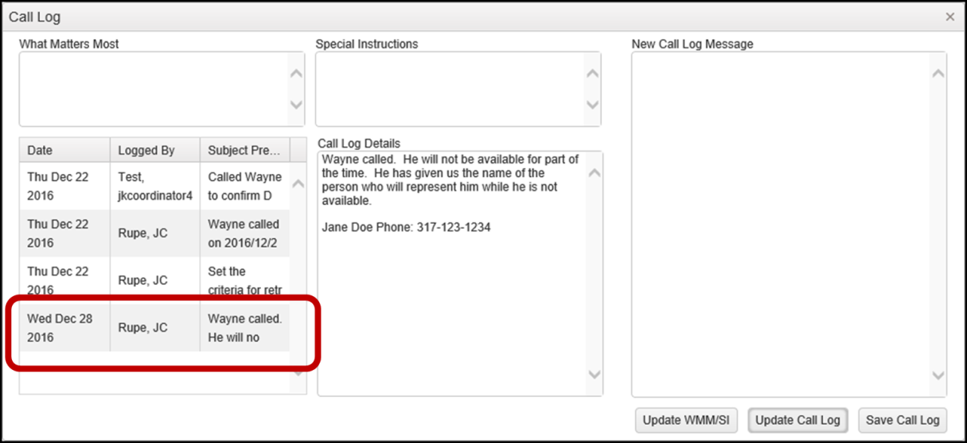

## Modify a Job’s Service Type

These steps show how to modify the “Service Type” of a Service Activity. This table shows what Service Types may be changed and what they may be changed to.

|  |  |
| --- | --- |
| **From Service Type** | **To Service Type** |
| Delivery | SIT at Origin |
| Delivery | SIT at Destination |
| More Than 1 | SIT at Origin |
| More Than 1 | SIT at Destination |
| Load | APU-Floor |
| Load | APU-Trailer |

1. Locate the desired assigned Service Activity in the LD Board panel.
2. Right click on the Service Activity.
3. Select the “Change Service” option in the dropdown menu.
4. Select one of the Service Types displayed. Here we are selecting “APU-Floor”.

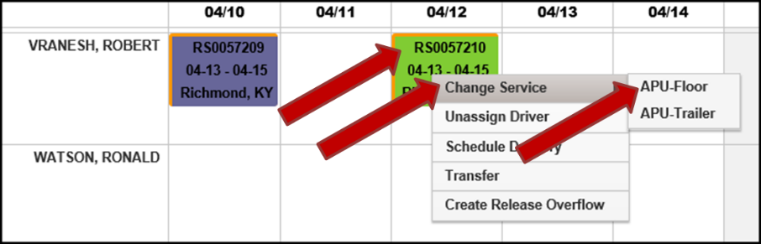

1. The “Service Activity Mod” window will display,
2. Enter any pertinent information.
3. Select the “Save” button.
   1. Note: By default, in this instance, a Release will be created on the date entered.

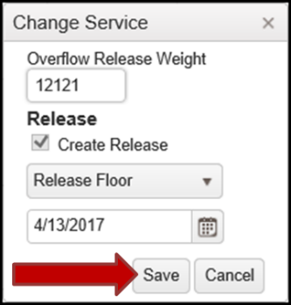

1. The Service Activity has now been changed to Service Type “APU”.
   1. The background color changed to pink, denoting that it is Service Type “APU”.
   2. The Release was created and assigned to the Driver on the date entered.

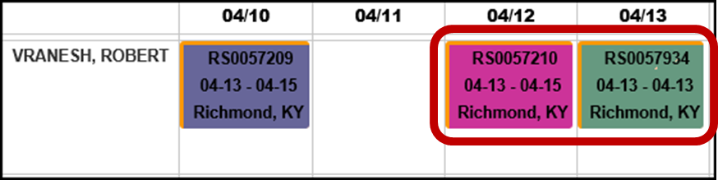

## Schedule Delivery and Create Release

Currently, both the Delivery and Release are created at the same time. One can’t be created without the other.

1. Locate the assigned Service Activity that needs a Delivery Scheduled
2. Right click on the Service Activity.

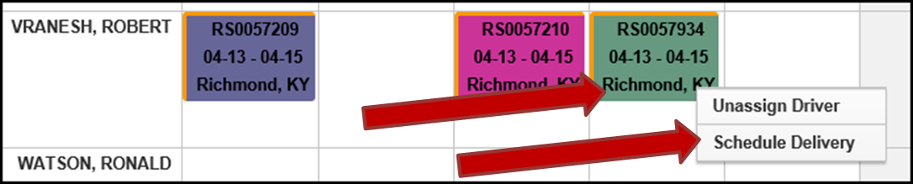

1. Select the “Schedule Delivery” option from the dropdown menu.
2. The “Schedule Delivery” window will display.

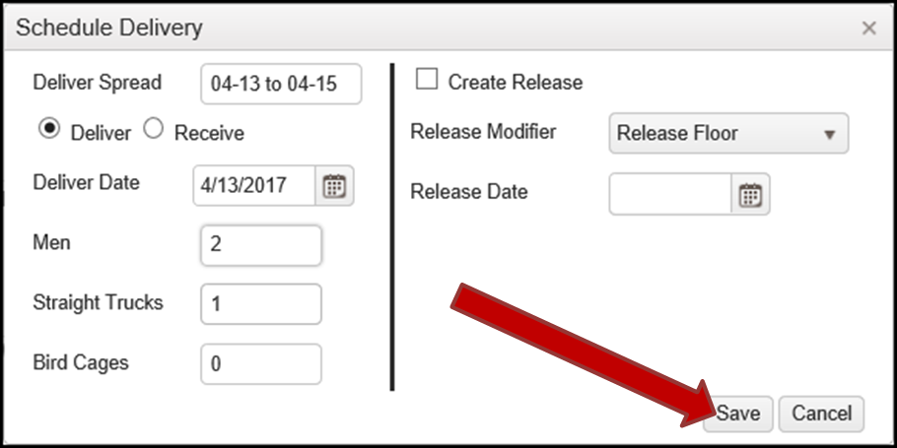

1. Enter appropriate Delivery information in the left side of the window.
   1. **Deliver Spread** – The date range for the delivery.
   2. Select either (radio button):
      1. **Deliver**
      2. **Receive**
   3. **Deliver Date** – The date the Deliver is to be scheduled.
   4. **Men** – The number of men required to perform the work.
   5. **Straight Trucks** – The number of Straight Trucks required for the job.
   6. **Bird Cages** – The number of Bird Cages required for the job.
2. If a Release is needed, enter appropriate Release information in the right side of the window.
   1. Place a check in the **Create Release** checkbox
   2. Select an option for **Release Modifier**.
      1. Options are:
         1. Release Floor
         2. Release Trailer
         3. Release
   3. Enter a **Release Date.**
3. Select the “Save” button.
4. Message(s) will display:
5. A message will display stating that a Service Activity of Deliver was successfully created.
   1. If a Release was needed and appropriate Release information entered, then a similar message will display stating that the Release was successfully created.



1. The newly created Delivery job will appear in the appropriate calendar position for the Driver.

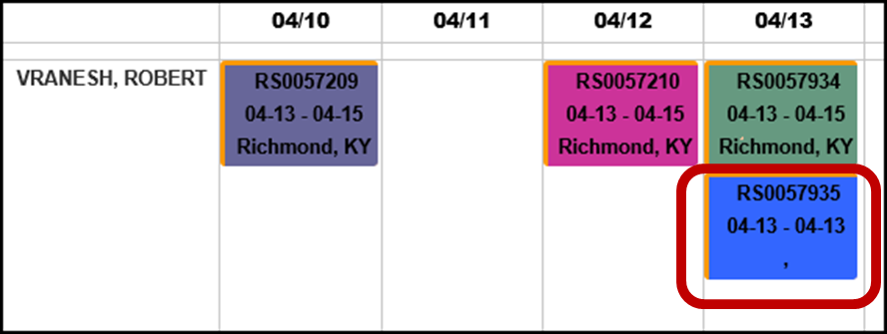

## Transfer a Job

Here you may transfer a Job from one Driver to another somewhere en route. This may mean moving the actual load from one truck to another, hitching a new Driver and truck to a trailer, etc.

1. Locate the Job to be transferred, in the LD Board panel.
2. Right click on the desired job.
3. Select the “Transfer” option in the dropdown menu.

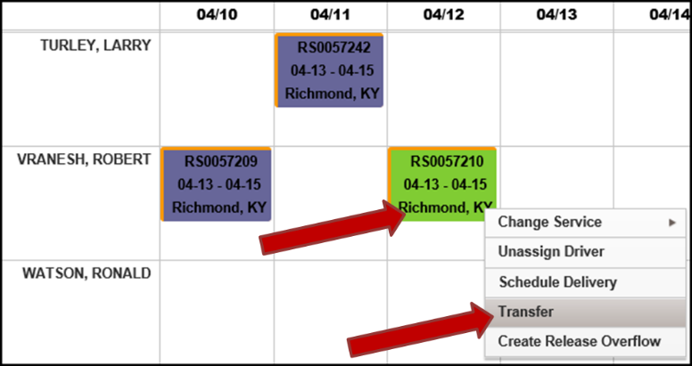

1. The “Service Activity Transfer” window will display.
   1. Enter appropriate information.
      1. **Driver to Transfer To –**
      2. **City**, **State** and **Zip** – Where the actual transfer will occur.
   2. Select the “Save” button.

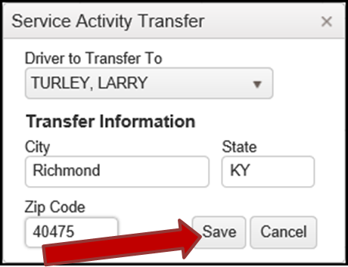

1. Two Transfer jobs will now be displayed in the LD Board panel.
   1. One in the appropriate calendar position for the Transfer From Driver.
   2. One in the appropriate calendar position for the Transfer To Driver.

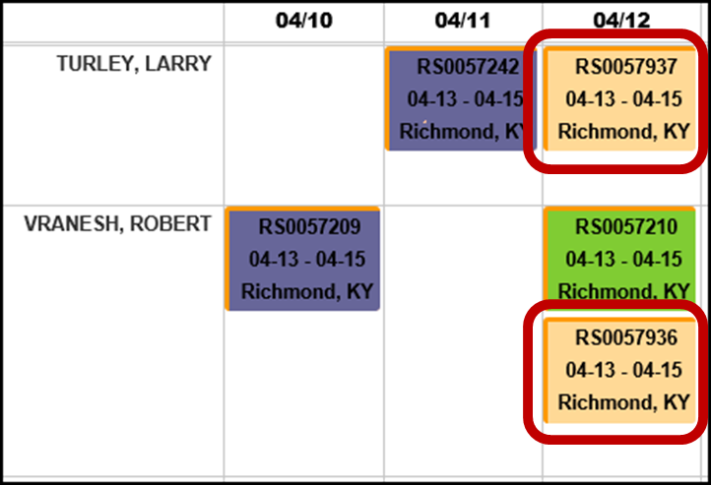

## Training Event

Setting a Training day(s) for a Driver indicates the date(s) the Driver is unavailable due to training activities.

### Create Training Event

1. Locate the Driver to have Training.
   1. Click select the day the Driver is to have Training.

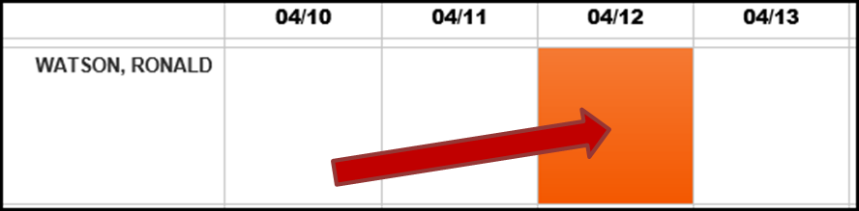

1. Right click somewhere in the highlighted days.
   1. Select the “Training” option.

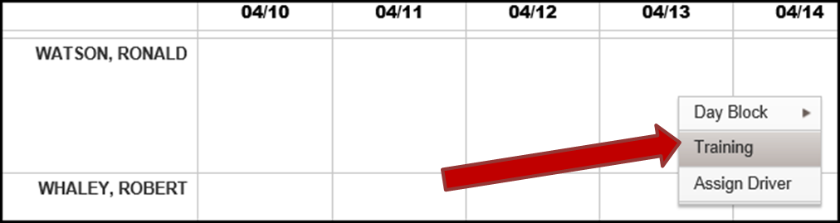

1. The “Training” window will display.
2. Enter appropriate information into the “Training” window.
   1. **No. of Men** – the number of men to attend the training.
   2. **Hours** – the number of hours the training will last.
3. Select the “Save” button.

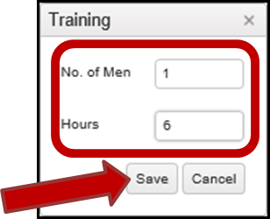

1. The “Training” window will vanish.
2. The Training event will now be displayed.

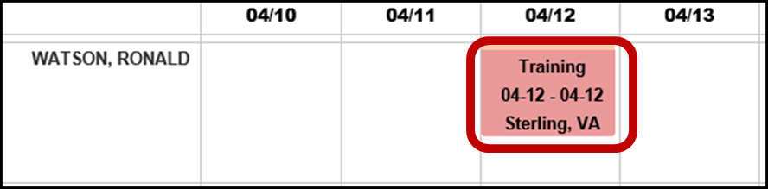

### Remove Training Event

1. Locate the Driver with the Training event.
2. Right click on the Training event.
3. Select the “Remove Training Service Activity” option.

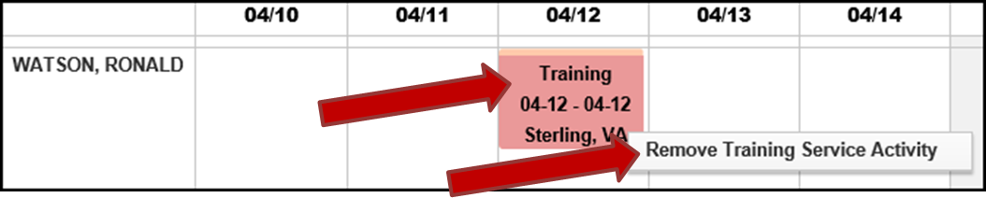

1. The Training event is now gone.
   1. **Note:** The entire Training event is removed. You can’t remove just one day from one slot if the event spans multiple days.

## Day Blocks (Events)

Day Blocks are special activity types or events that exist to show why a driver is unable to be scheduled for jobs for specific date(s) on the scheduler. The block is for the full day, midnight to midnight.

### Create a Day Block

1. Locate the Driver to have a Day Block.
   1. Click and drag to select the days the Driver is to have a Day Block.

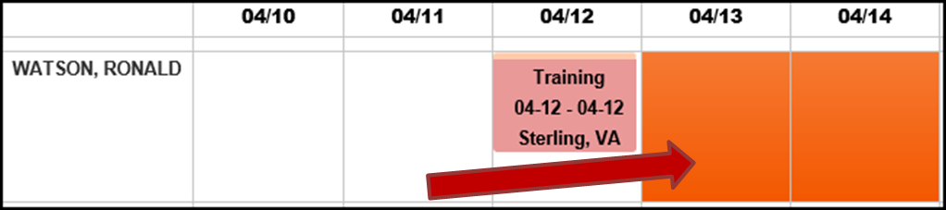

1. Right click on the selected/highlighted days.
2. Select “Day Block” option from the dropdown menu.
3. Select which type of Day Block.
   1. **Off** – For Time Off for a day or more.
   2. **Pack** – Driver is packing.
   3. **Drive** – Driver is in transit.
   4. **Delay** – There is a delay.
   5. **Breakdown** – Vehicle is broken down in transit.

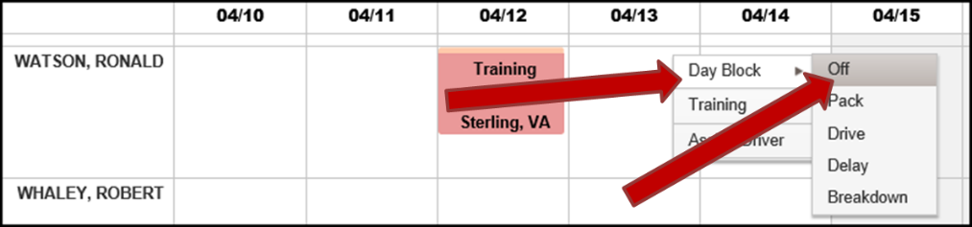

1. The LD Board panel will refresh.
   1. The Day Block will be displayed covering the appropriate dates.

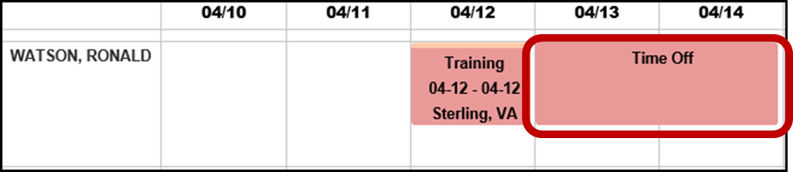

### Remove a Day Block

1. Locate the Driver with the Day Block that is to be removed.
2. Right click on the Day Block.
3. Select “Remove Day Block”.

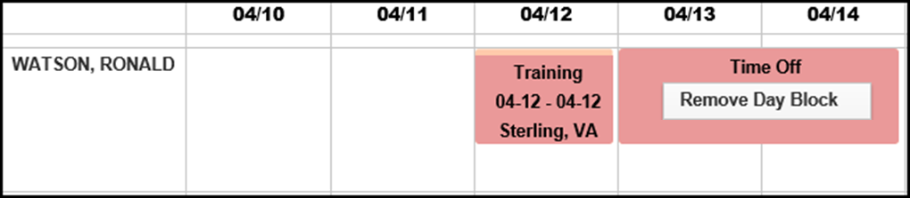

1. The Day Block is now gone.
   1. **Note:** The entire Day Block is removed. You can’t remove just one day from one block that spans multiple days.

